LUMEN™ EASE Customer Impact Bulletin

Date of Notification:
Subject: ASOG 63 – Initial Customer Notification (Day 72/60)
System(s) Impacted: EASE, UOM
Areas Impacted: ASR customers (IXC, Wireless, CLEC, ISP)
Date Effective: 09/18/21

Effective Saturday, September 18, 2021, Lumen will implement Versions 63 of the Access Services Ordering Guidelines within its Pre-Order and Ordering Interface systems.
During the release implementation, EASE VFO (Virtual Front Office) and UOM (Unified Ordering Model) will be unavailable for processing transactions from 5:00 PM ET on September 17 , 2021 until 7:00 AM ET on Monday, September 21, 2021.

ISSUES INCLUDED IN THIS SYNOPSIS
ISSUE NUMBER | DESCRIPTION
3643 | OBF Issue 3643, Update the meet point exchange process defined by Issue 3464, MECOD: Develop a more standardized provider to provider process for the communication of meet point information -- Released with ASOG 63, Implemented with ASOG 63.
3654 | ASOG: Prohibited Special Characters
3655 | ASOG: Modify CNT value to acknowledge PRE-FOC Jeopardy

With the ASOG 63 release on September 18, 2021, Lumen will support the following ASR modifications

ASR FORM |  | ASR 61 Modification
000a |  | Section 2.4 Conventions  Addition of Allowable Special Characters  Character Description  % (percentage)  $ (dollar sign)  @ (Email "at" sign)  # (number sign)  & (ampersand)  ( ) (open close parentheses)  { } (open close brackets)  [ ] (open close brackets)  * (asterisk)  / (forward slash)  \ (back slash)  ' (apostrophe)  ! (exclamation)  . (period)  " (quotation)  : (colon)  + (plus)  - (minus/dash)  _ (underscore)  , (comma)  ; (semi-colon)  ? (question mark)  " " (a space)  = (equal)  | (vertical bar)  ~ (tilde)  ` (back accent)  LUMEN will require that the following special characters be encoded due to XML constraints  - &amp; (&)  - &quot; (")  - &apos; (')  In addition to existing symbols:  - &lt; (<)  - &gt; (>)
010 |  | Modification to allow Pre-FOC Jeopardies – Please see information after the matrix regarding LUMEN implementation for inflight orders.
010 | 12.CNT | Addition of values “G”, “H” to Valid Entries and addition of Valid Entry Notes 7 and 8.  12. CNT - Clarification/Notification Type  Identifies the type of clarification/notification being sent to the customer.  VALID ENTRIES:  A = ASR (PON) Completion  B = Jeopardy  C = Previous C/NR Clear  D = Remarks  E = Errors  F = Jeopardy with errors  G = Pre-FOC Jeopardy  H = Pre-FOC Jeopardy with errors  K = Provider Initiated Cancellation  L = Address Modification  NOTE 1: An entry of “A” indicates the following:  - ASR (PON) has been marked as completed by the provider, service has been activated and billing may commence.  - The ASC-EC defined common completion date should be used by all EC’s involved in a MULTI-EC ordering scenario.  - In a MULTI-EC ordering scenario, all EC’s involved should follow the completion coordination process defined in ATIS-0404120 Multiple Exchange Carriers Ordering and Design (MECOD); ASSUMPTIONS and COMPLETION sections.  NOTE 2: An entry of “B” indicates the ASR (PON) has a condition which impacts the critical date(s). The use of “B” is only applicable after the ASR has been confirmed.  NOTE 3: An entry of “C” indicates that all the conditions that would have required clarification from the customer have been satisfied. This could have occurred as the result of a SUP being received or through verbal negotiations between the customer and provider that determined a SUP is not required. The use of “C” is only applicable after a previous C/NR has been issued with an entry in the SUPR field.  NOTE 4: An entry of “D” indicates that the C/NR is informational only and no response is required.  NOTE 5: An entry of “E” indicates that one or more ERROR TAG fields are populated on the C/NR.  NOTE 6: An entry of “F” indicates the combination of “B” and “E” conditions.  NOTE 7: An entry of “G” indicates the ASR (PON) has a condition which impacts the return of a FOC. The use of “G” is only applicable prior to the first confirmation for the ASR.  NOTE 8: An entry of “H” indicates the combination of “G” and “E” conditions.
010 | 19. SUPI | Modification of Usage Note 1  19. SUPI - SUP Indicator  Identifies that the provider expects a supplement ASR to correct the condition identified at the line level on the C/NR.  VALID ENTRIES:  Y = Yes  NOTE 1: If this field is blank, the clarification/notification for this line item is informational only.  USAGE: This field is conditional.  NOTE 1: Optional when the CNT field is “B”, “E”, “F”, “G”, “H”, or “L” otherwise prohibited.
010 | 20. RCODE | Modification of Usage Note 1  20. RCODE – Reason Code  Identifies the reason the provider has placed this service request in jeopardy status.  NOTE 1: This indicates the ASR (PON) has a condition that impacts the critical date(s) and is only applicable after the ASR has been confirmed.  VALID ENTRIES:  1A = Inter Office Facility Shortage  1B = Scheduling/Work Load  1C = Customer Not Ready  1D = No Loop Available  1E = End User Not Ready  1F = Provider Missed Appointment  1G = No Access to End User Premise  1H = Central Office Freeze  1J = Special Construction  1K = Natural Disaster (Flood, etc.)  1L = Frame Due Time Cannot Be Met  1M = Due Date Cannot Be Met  1N = Due Date and Frame Due Time Cannot Be Met  1P = Other  1Q = Assignment Problem  1R = Customer Could Not Be Reached  1S = Building Not Ready, Customer Will Advise  1T = Pole At Site Not Set  1W = Entrance Facilities Required  1X = Not Technically Feasible  1Y = No Central Office Equipment Available  1Z = Other Exchange Company Not Ready  USAGE: This field is conditional.  NOTE 1: Required when the CNT field is “B”, “F”, “G”, or “H”, otherwise prohibited.
010 | 45. ERROR TAG | Modification of Usage Note 1  45. ERROR TAG - Error Tag  Identifies a specific field or unique identification scheme for the error message provided in the ERROR MESSAGE field.  VALID ENTRIES:  ASOG data element  Unique error code  SVC-ADDR = Service Address  NOTE 1: The valid entry “SVC-ADDR” indicates one or more data elements associated with the service address on the SALI Form is in error. In lieu of “SVC-ADDR”, the specific ASOG data element may be used (e.g., CITY) as stated in Note 2.  NOTE 2: Identifies the name of the field (e.g., NCI) in error as shown in the ASOG.  NOTE 3: Identifies an error condition that cannot be mapped to a specific ASOG data element.  USAGE: This field is conditional.  NOTE 1: Required when the CNT field is “E”, “F” or “H”, otherwise prohibited.

LUMEN Implementation of the PRE-FOC jeopardy notification
- The Order list will display the above jeopardy names for any jeopardy responses after the ASOG 63 cutover. Any existing Jeopardies, will retain the previous “Jeopardy” or “Jeopardy with Errors” status.
- The use of the PRE-FOC jeopardy values is only applicable on the initial FOC issuance for the PON.

Modifications to the EASE VFO Filter Page
- The filter will include the two new jeopardy status names as well as revised current “Jeopardy” and “Jeopardy with errors” values.

- They will appear in the Access Section as:

  - Jeopardy/Post-FOC Jeopardy
  - Jeopardy with Errors/Post-FOC Jeopardy with Errors
  - Pre-FOC Jeopardy
  - Pre-FOC Jeopardy with Errors

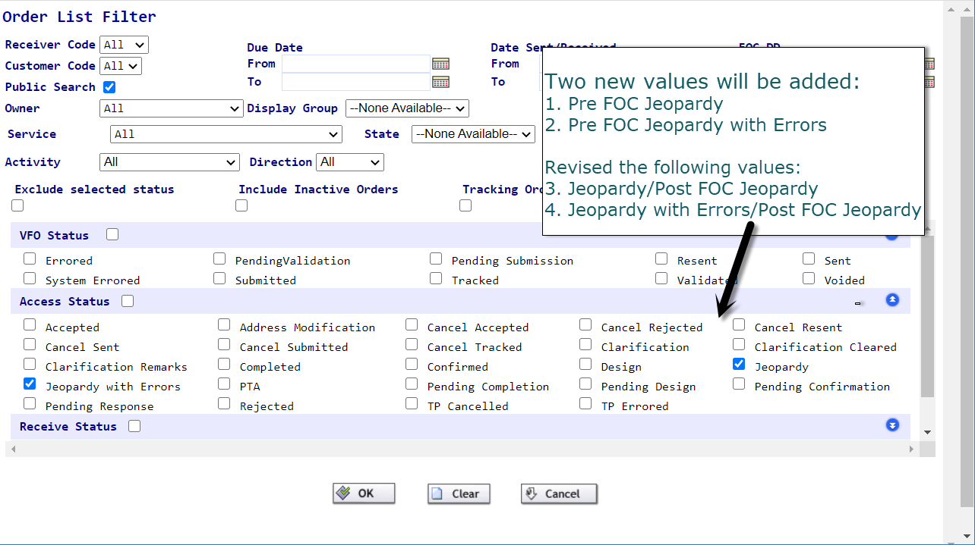
- Under the Receive Status, they will appear as:
  - Jeopardy/Post-FOC Jeopardy
  - Jeopardy with Errors/Post-FOC Jeopardy with Errors
  - Pre-FOC Jeopardy
  - Pre-FOC Jeopardy with Errors

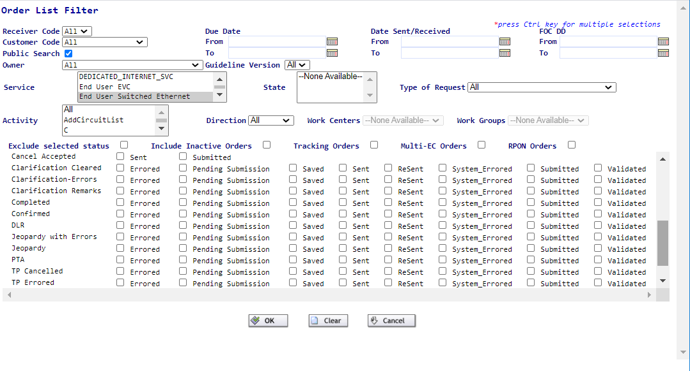

Lumen will not support the following modifications with ASOG 63:
FORM | Field | ASR 63 Modification

With ASOG 63, Lumen will modify custom business rules including, but not limited to the following:
(Please NOTE: A complete list of EASE custom edits can be viewed by clicking on the web-link for ASR Lumen Custom Business Rules available from the EASE Homepage in the Guide (ASR) TAB.)

ASR Form | Field | EDIT type | BUSINESS RULE / WEBCALL / EDIT | ERROR CODE | REQUESTED ACTION | Legacy Company

Lumen would like to use this notification to also provide an additional communication of upcoming company holidays. Lumen looks forward to providing any order assistance on the next business day following the holiday dates listed below.

Holiday | Date | Date Observed | Exceptions
Labor Day | 9/6/2021 | 9/6/2021
Thanksgiving | 11/25/2021 | 11/25/2021
Day After Thanksgiving | 11/26/2021 | 11/26/2021
Christmas Eve | 12/24/2021 | 12/24/2021
Christmas | 12/25/2021 | 12/27/2021 | Company Holiday – LC Retail Only

